SECOND GOAPPLE PREVIEW

JAMES QUINTERO MOSQUERA

GIORGI JULIÁN ORDOÑEZ

ING. ROBINSON GOMEZ

CORE TECHNOLOGIES: HTML, CSS, JAVASCRIPT, PHP AND MYSQL

MODALITY: GROUP DEVELOPMENT

FOUNDATION FOR HIGHER EDUCATION FESC

CLIENT-SERVER ARCHITECTURE
SAN JOSE OF CUCUTA
MARCH 9, 2026
SPANISH VERSION

PRACTICAL GUIDE #5: REMOTE OBJECT INTEGRATION AND SERIALIZATION

ACTIVITY 1: DEFINITION OF INTERFACES AND SERIALIZABLE CLASSES
Within the GOAPPLE project, the Product class was defined as the exchange object, since the system is oriented towards the management of technological products.
Product Class (Serializable)
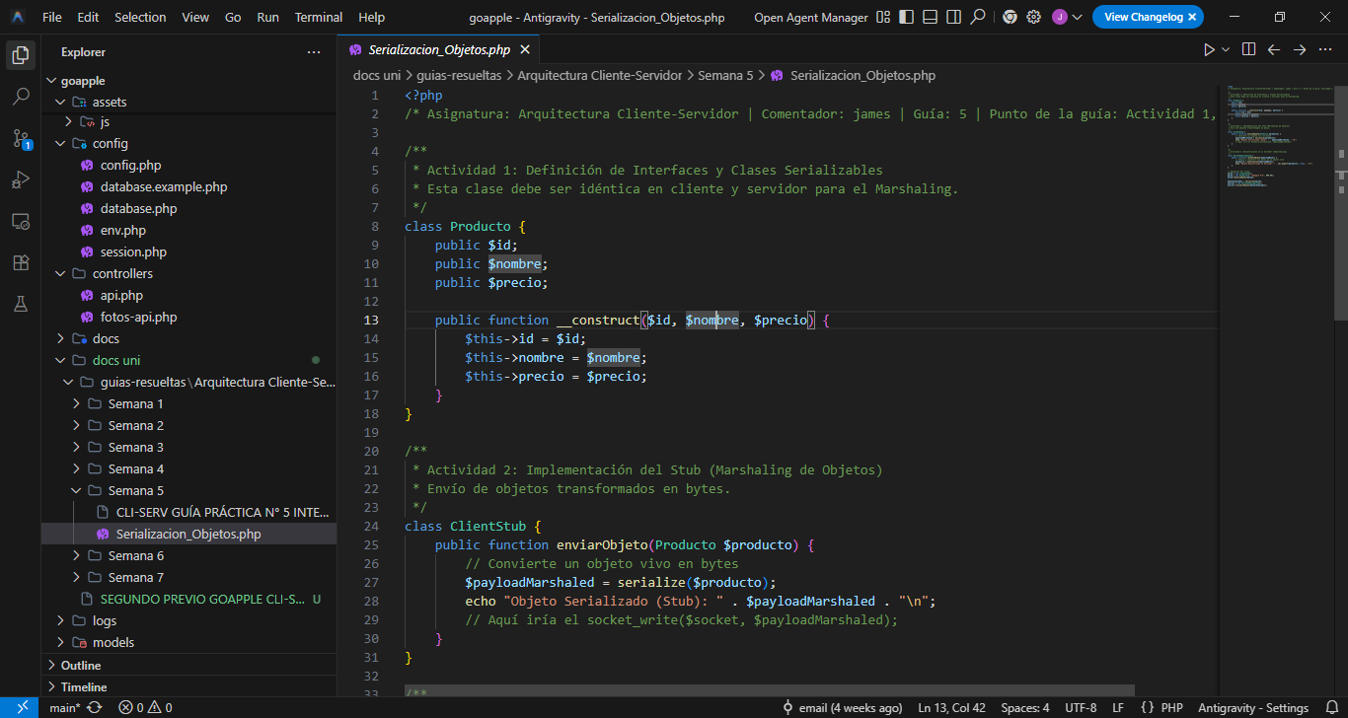
This class must exist exactly the same on both the client and the server to ensure the correct marshaling process.

ACTIVITY 2: IMPLEMENTATION OF THE STUB (MARSHALING)
A StubClient class was implemented to encapsulate the sending of the Product object to the server.
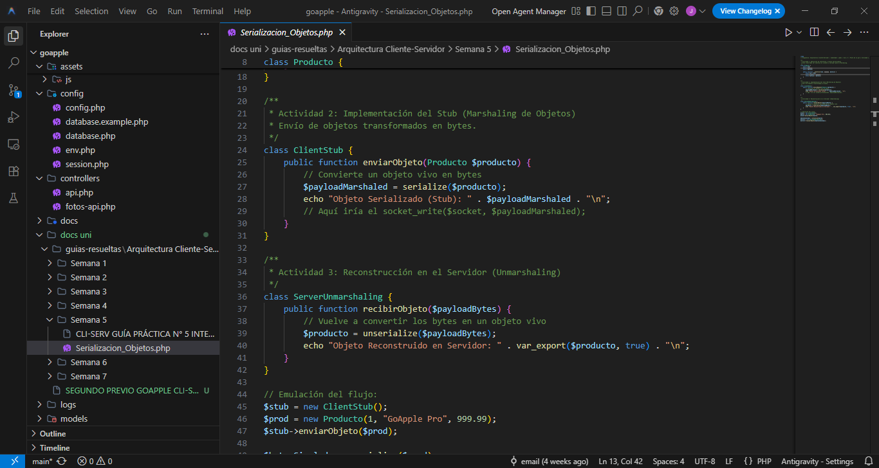
Customer Core Program:
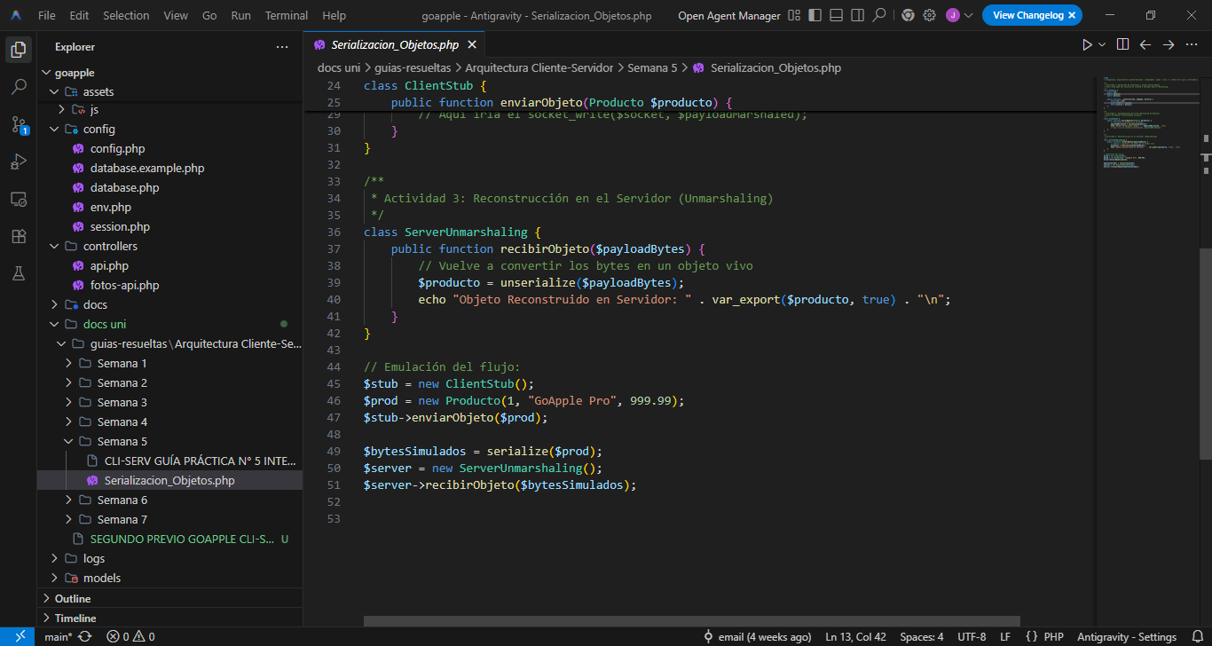
Here, the client only invokes a local method. The stub handles the serialization and socket transmission process.

ACTIVITY 3: RECONSTRUCTION OF THE OBJECT ON THE SERVER (UNMARSHALING)
The server receives the byte stream and reconstructs the Product object.
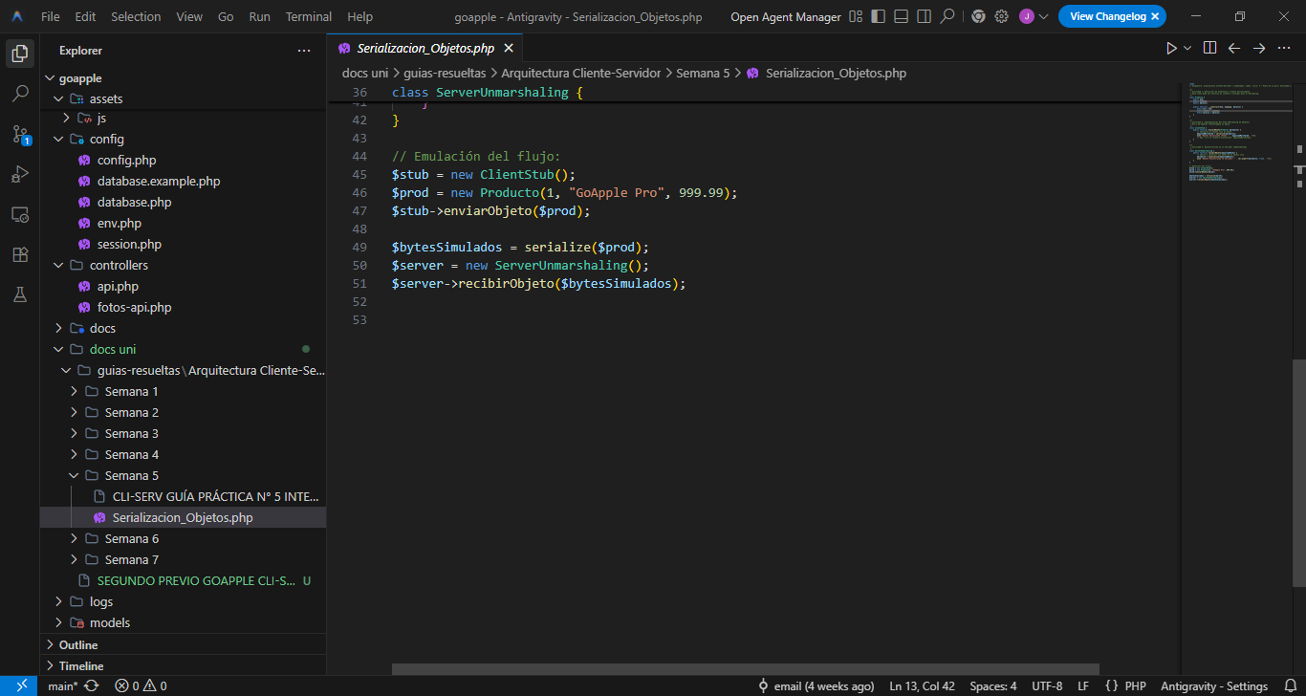
This validates that the reconstructed object maintains exactly the same data sent from the client.

CONCLUSIONS
- Serialization allows the transfer of complete objects between distributed processes.
- Stubs improve system transparency by hiding the complexity of sockets.
- The marshaling and unmarshaling processes were found to preserve object state.
- This implementation provides a foundation for building more complex remote services in Google Apple.

PRACTICAL GUIDE #6 IMPLEMENTATION OF THE NAMING AND REGISTRATION SYSTEM

ACTIVITY 1: CONFIGURATION OF THE DIRECTORY SERVICE (REGISTRY)

- Program a standalone module on the server to function as a lookup table.
- Implement a data structure (e.g., an associative array or a lightweight database) where the "Service Name" is stored, linked to its "Network Address" (IP and Port) or the corresponding serialized object.
- Key concept: The Registry must be able to process Bind and Lookup requests.

ACTIVITY 2: SERVICE REGISTRATION PROTOCOL

- Modify the server side so that, upon startup, the remote object is automatically advertised to the Registry.
- Implement availability validation: if the service already exists with that name, the Registry must manage the reference update to ensure interoperability.

ACTIVITY 3: DYNAMIC SEARCH FROM THE CLIENT (NAMING SYSTEMS)

- Remove hardcoded IPs from the client code.
- Program the client to first query the Registry by sending the logical service name. desired.
- Use the Registry response to transparently establish the final connection to the remote object.

EVIDENCE
